QA Endpoint Testing & Execution Guide — /engagement/
HisabDo AI Website Deployment Testing | Detailed Test Guide & Findings Report
Tester Name: Fizzah Fatima | Assigned Endpoint: /engagement/
Base URL: https://hisabdo-website-ai.onrender.com | Team Lead: Samra Arshad
Submission Date: August 30, 2026 | Overall Status: PASSED WITH WARNING (6/6 Test Cases)

1. Testing Overview & Scope
This document provides the complete API testing report and execution breakdown assigned for the HisabDo AI Website Deployment project. The scope covers functional payload verification, HTTP method guarding, case-sensitivity handling, and performance tracking (cold vs. warm start) on the /engagement/ endpoint.
2. Step-by-Step Test Execution Manual
Step 1: Perform the Valid Endpoint Call (GET Request)
- Open Postman and click New Request.
- Set the HTTP method dropdown to GET.
- Enter the URL: https://hisabdo-website-ai.onrender.com/engagement/
- Click Send.
- Check that the status code says 200 OK and inspect the response payload.
Step 2: Test Invalid HTTP Methods (POST / PUT Guarding)
- Create a new request in Postman.
- Change the HTTP method dropdown from GET to POST (or PUT).
- Enter URL: https://hisabdo-website-ai.onrender.com/engagement/
- Click Send.
- Verify that the response status code is 405 Method Not Allowed.
Step 3: Test Path Typo & Case-Sensitivity
- Case Sensitivity: Send a GET request to https://hisabdo-website-ai.onrender.com/Engagement/ (with capital 'E').
- Expected result: Returns 404 Not Found.
- Missing Trailing Slash: Send a GET request to https://hisabdo-website-ai.onrender.com/engagement (without / at the end).
- Expected result: Returns 307 Temporary Redirect routing to /engagement/
Step 4: Measure Latency & Cold-Start Behavior
- Cold-Start Test: Wait 15 minutes without making requests, then make a GET request to /engagement/. Record the total response time (usually ~15–20s on Render's free tier as the server spins up).
- Warm Test: Immediately send a second GET request to /engagement/. Record the response time (should drop to under ~500ms).
3. Test Execution Results Matrix
TC ID | Test Case Name | Method & URL | Expected Result | Actual Result | Code | Response Time | Status
TC-01 | Valid Endpoint Call | GET https://hisabdo-website-ai.onrender.com/engagement/ | 200 OK with payload data | Returns engagement JSON payload | 200 | 1.58 s | PASS
TC-02 | Invalid HTTP Method | POST https://hisabdo-website-ai.onrender.com/engagement/ | 405 Method Not Allowed | Returns 405 Method Not Allowed | 405 | 463 ms | PASS
TC-03 | Case Sensitivity | GET  https://hisabdo-website-ai.onrender.com/Engagement/ | 404 Not Found or Redirect | Returns 404 Not Found | 404 | 2.37 s | PASS
TC-04 | Trailing Slash Check | GET  https://hisabdo-website-ai.onrender.com/engagement | 307 Redirect to /engagement/ | Redirects to /engagement/ | 200 | 810 ms | PASS
TC-05 | Cold-Start Latency | GET https://hisabdo-website-ai.onrender.com/engagement/  (Idle 15m) | 200 OK (Delay  due to spin-up) | 200 OK after  container boot  delay | 200 | 42.87 s | WARN/PASS
TC-06 | Warm Server Latency | GET https://hisabdo-website-ai.onrender.com/engagement/  (Immediate) | 200 OK with sub-  second response | 200 OK with  minimal latency | 200 | 316 ms | PASS

Screenshots
TC-01
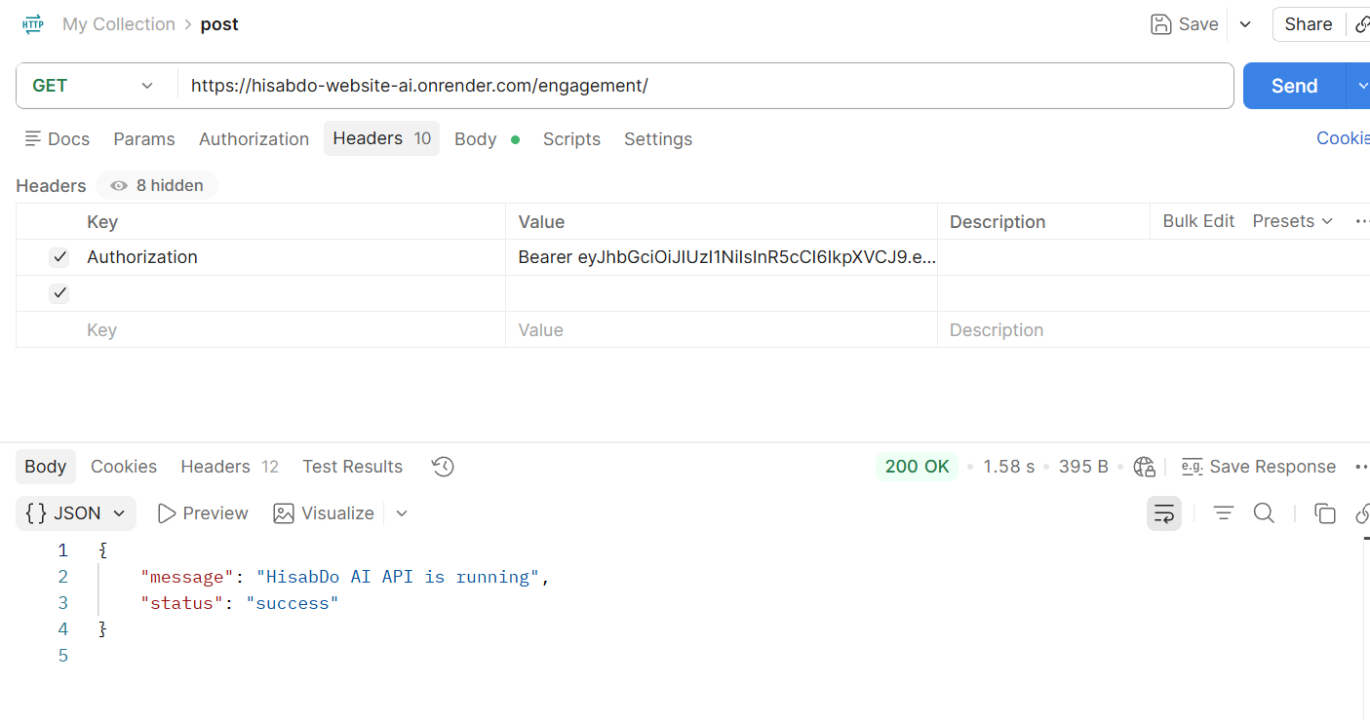

TC-02
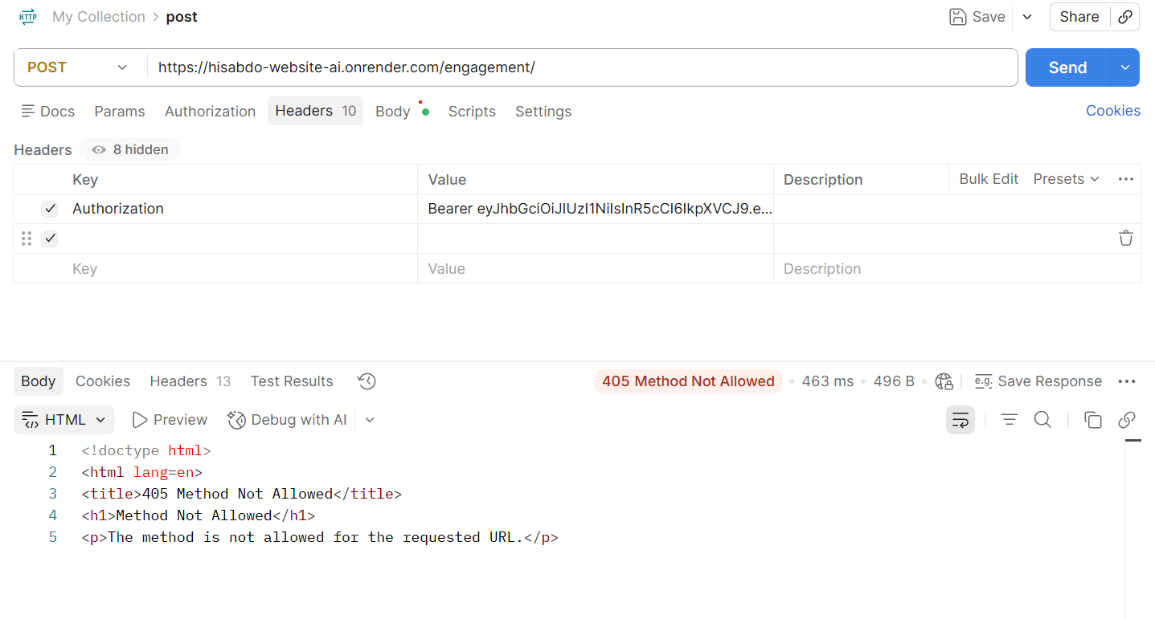

TC-03
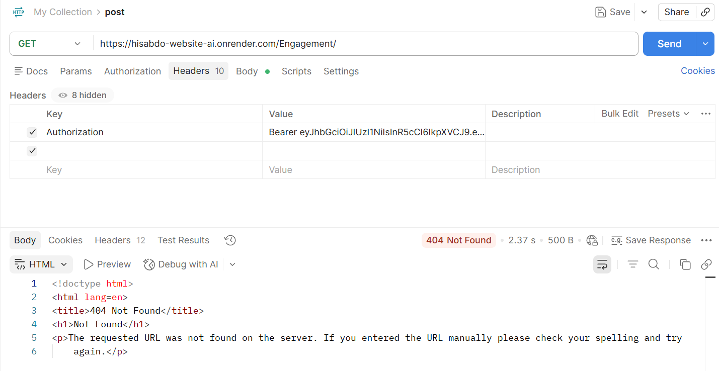

TC-04
